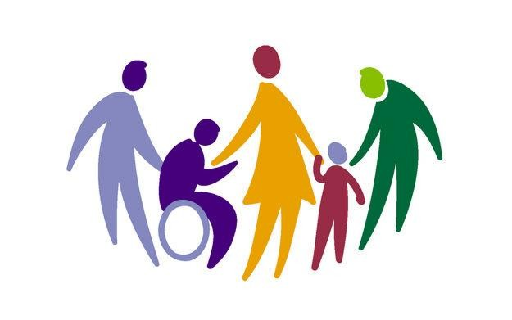

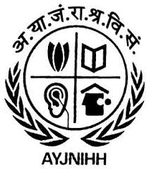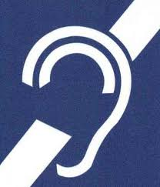

REHABILITATION PROGRAMME FOR HEARING IMPAIRED.

COMMUNITY BASED REHABILITATION PROGRAMME

PROJECT REPORT

2016-18

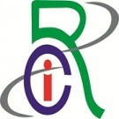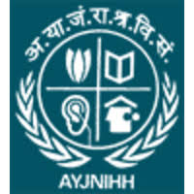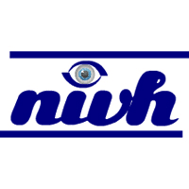DIFFERENTLY ABLE

SUBMITTED TO SUBMITTED BY

SMT. KIRAN TOMAR

ALI YAVAR JUNG NATIONAL INSTITUTE OF SPEECH AND HEARING DISABILITIES (DIVYANGJAN), MUMBAI